|  |
| --- |
|     Demo Neighbourhood  in Gneis District, Salzburg, Austria  This is an example to give new users an idea of how to use the MBx tool by following a step-by-step process.  In practice, identifying multiple-benefits (impacts) and generating the inputs is more complex, requiring  evidence and iteration. |
|  |
|  |

Steps 1 to 3: Inputs for MBx tool 3

Step 1 - Define initiative and business-as-usual scenario 3

Step 2 - Identify those who gain and those who lose 4

Step 3 - Identify the benefits and costs, allocate to time periods 4

Steps 4 to 5: Analysis in MBx 10

Step 4 - Quantify the costs and benefits 10

Step 5 - Discount to a common period, compare with costs and benefits 10

Steps 6 to 7: Outputs from MBx tool 11

Sensitivity analysis involves working through some alternative scenarios. 11

Step 6 - Is the result clear enough? 12

Step 7 - Write report – provide advice 12

Description of the outputs 12

Demo Neighbourhood in Gneis District, Salzburg, Austria

|  |  |
| --- | --- |
|  |  |

Initiative

Development of 17 buildings, new built and renovation of 250 social housing dwellings   
and kindergarten in an existing neighbourhood.

Description

Neighbourhood approach Caritas together with a highly motivated +55-year-old community   
group “Wohngruppe Silberstreif” are shaping the neighbourhood’s atmosphere. The social   
housing provider offers advice and consulting services about energy use and home   
renovation and is working together with residents to set up a self-sufficient energy community.   
The premises will also include facilities such as a kindergarten, doctor, café, co-working   
spaces, common rooms and special assistance rooms.

|  |  |
| --- | --- |
| Steps followed in MBx tool | |
| Inputs | **Step 1** - Define initiative and business-as-usual scenario  **Step 2** - Identify those who gain and those who lose  **Step 3** - Identify the benefits and costs, allocate to time periods |
| Analysis | **Step 4** - Quantify the benefits and costs within ranges  **Step 5** - Discount to a common period, compare benefits and costs |
| Outputs | **Step 6** - Is the result clear enough? If not, consider whether it is worth investing in more research, repeat previous steps  **Step 7** - Report results |

**NOTE:**

Text in GREY = General description of the step / Text in PURPLE = Specific information from the use case

# Steps 1 to 3: Inputs for MBx tool

Before populating the S-CBA generate the information you’ll need **(the inputs)**. This involves establishing the evidence base and working through any assumptions.

It is useful to check out the **MBx Impacts Database** before doing your own research to help understand the types of metrics and impacts to look out for when researching. If your organisation has a dedicated research team, it is recommended that you engage with them early to assist with gathering evidence, as this can be the most time consuming but also most fundamental activity in completing a S-CBA.

## Step 1 - Define initiative[1] and business-as-usual scenario

The first step involves defining the initiative and identifying several potential options. For clarity some definitions to consider are:

|  |
| --- |
| **BAU:** the situation if the initiative would not exist **Initiative:** the set of measures that will be implemented **Potential options:** different alternatives of the initiative |

You should undertake the S-CBA for these potential options. Doing a draft S-CBA can clarify the main impacts, provide initial evaluation of the potential options, and help to focus the initiative and evidence efforts. In practice, it is an iterative process, where MBx inputs and results inform further options and evidence development.

If you think that there is more than one probable BAU scenario, you can run a S-CBA to test the scenarios for each one this is often called ‘sensitivity’ or ‘scenario’ analysis. See Step 6 for more on **sensitivity analysis. For now, just understand this involves modifying assumptions in the existing model rather than re-running an entire S-CBA.**

In this example, define the business-as-usual (BAU) of the initiative, that is, the situation that would exist if the initiative does not go ahead. Let’s assume that business-as-usual is ‘no change to current practice’. In this case we will assume that the neighbourhood has no community-oriented design and planning with no or very limited shared facilities or services to the community.

|  |  |  |
| --- | --- | --- |
| Scenarios | | |
| Build a neighbourhood with 250 households | vs | Business-as-usual (BAU) |
| Build a neighbourhood with 250 households | vs | Build a neighbourhood with 50 households |

|  |
| --- |
| Lights On with solid fillHints  You need to have a good sense of the challenges, issues or problems and the target group for the initiative (project/policy). You should consider questions like:   * What is the status quo? What are the current impacts of ‘business as usual’? * Would an initiative intervention for the same problem be provided by someone else? * What other factors already affect the multiple benefits (impacts)? * What would you do if you did not undertake the proposed initiative? What is the next best alternative? * Are there other things that might influence the situation? If the initiative does not get funded, would the problem remain the same, or decline over time, or get better? |

**Step 2** - Identify those who gain and those who lose

Next, we identify who is going to be impacted, both positively and negatively, by the initiative. An initiative can have numerous positive and negative impacts (fiscal and non-fiscal benefits and costs) occurring at different future years, and each of these might apply to a different group of people.

When identifying the people who are impacted through this neighbourhood, think about the people who may experience gain as well as those who get negative impacts. In this example, it is assumed that the negative impacts of neighbourhood are negligible as there are no adverse reactions.

Be as specific as possible for each impact. Include people who gain and lose outside the immediate organisation and sector. Try to capture all people affected by the intervention. Note that some impacts might be easier to monetise than others.

In this example, the main group that stands to gain are 250 households including people of all genders and age groups.

* Senior citizens (60 or above)
* Adults (18- 59)
* Children (birth-17)

The implementation of the project will take place during 2024 to 2026. The allocation of the apartments will take place in the beginning.

We will assume that 80 households will move in the project in 2024 and 2025 followed by 90 in 2026. Due to financial year (e.g. March/June) the move-in year is the following year as in the table.

|  |  |  |  |  |
| --- | --- | --- | --- | --- |
|  | 2024 | 2025 | 2026 | 2027 |
| No. of households | - | 80 | 80 | 90 |

These households are assumed to have a family size of 4. Therefore, a total of 1000 inhabitants (30% senior citizens, 40% adults and 30% children) would be impacted by the development of this neighbourhood. In this example, the primary receiver of multiple benefits are the senior citizens, adults and children.

|  |
| --- |
| Lights On with solid fillHints  Think broadly about the impacts. ‘Casting the net’ wide early on can help to identify impacts that aren’t immediately obvious, but which may change the pitch of the funding proposal and those you need to engage with. You should consider questions like:   * Who might gain? * Who might lose? * Who might be affected, and in what way? |

## Step 3 - Identify the benefits and costs, allocate to time periods

To complete Step 3, you will need to produce the following information:

* **Cost of the initiative** (up front and ongoing, including both operating and capital)
* **Impacts[2] of the initiative** (either negative or positive)
* **Identification of impacts** using impact pathway
* **Segment of the intervention group impacted per year** (or part) using estimates, as well as how they might be affected
* **Timing giving an estimate when each impact will start and how long it will last for**
* **Probability/ success rate** (i.e., the probability of success for the number of attempts) of each impact occurring for those impacted
* **Evidence quality** indicating the judgement on the proof supporting the evidence
* **Magnitude of impact** indicating an estimate of how large the impact will be
* **Pre- and post-intervention levels** indicating the estimated level of impact before and after the intervention

Keep a record of the information that you use for making assumptions and developing the input for your S-CBA.

Cost of the initiative

Costs include total investment costs (including any operating and capital expenditure), maintenance costs and energy costs (operating expenditure) incurred through the lifetime of the initiative. This is a whole of life costs approach. You only need to include total annual operating and capital expenditure. However, these should be for the entire length that funding would be made available i.e., not just the budget year and outyears (up to 50 years).

All costs and values should be in today’s euros (i.e., in **real terms**). Costs should be in the base (current) year prices and measured in base year euros - you do not need to adjust for inflation. The MBx tool applies **discount rates** automatically and you do not need to discount the costs, or the impacts, that you input. The initiative costs should be supported by and sourced from detailed financial calculations outside the MBx tool. This should cover the details of the fixed costs that do not change with the scale of the initiative, and the variable costs and the drivers of the variable costs. For example, doubling the number of people that are covered in the initiative may only increase the initiative costs by half, and improve the initiative’s ROI and value for money. Ensure that impacts and costs are entered for the same initiative scale.  
  
In the example

**Total project investment:**   
€75 millions (to be spent in first 3 years)

**Maintenance costs:**   
4 €/(m²a)- applied to total calculation period

**Energy costs:**   
4 €/(m²a)- applied to total calculation period

**Cost for total area:**   
10,000 m2 (total heated floor area) x 8 €/(m²a) = 80,000 € per annum

Financial year ending (31st March) marks the final budget spending.

|  |  |  |  |  |  |  |
| --- | --- | --- | --- | --- | --- | --- |
| Year ending | 2024 | 2025 | 2026 | 2027 | …. | 2072 |
| Capital expenditure (€) | - | 25 m | 25 m | 25 m | 0 | 0 |
| Operating expenditure (€) | - | 80,000 | 80,000 | 80,000 | 80,000 | 80,000 |

Impacts of the initiative[3] (positive and negative)

The S-CBA focuses on estimating a monetary value of impacts i.e., monetising multiple benefits. Some of the impacts you have identified may be given a monetary value (monetised) using values in the **MBx Impacts Database.**

Currently, there are around ~40 monetised impacts in the **MBx Impacts Database**. All impacts are publicly available, and the source is provided in the database. If you have a relevant impact that is not in the database (and that has a monetary value), you can add it to the database at the bottom of the table for use in your analysis and have the option of sharing it with us to add it permanently in the database after further validation by our researchers.

It may be helpful to initially summarise impacts in a table as set out below. Think about the impacts on society more broadly (well-being from use and non-use) and within government – often changes in governmental costs and governmental revenues (fiscal impacts). Same measure could impacts at different levels (society and government), and all should be considered. Be as comprehensive as possible. Consider both gains / positive impacts and losses / negative impacts. Consider impacts across wellbeing domains and time.

The costs and benefits to government tend to be the easiest impacts to quantify because they are often already measured in monetary terms. Costs and impacts of government provided services (whether positive or negative) should generally be prepared on a minimum rather than average basis.

Many of these impacts are included in the MBx Impacts Database for easy use. Focus on quantifying and monetising the significant impacts, rather than all impacts.

|  |  |  |
| --- | --- | --- |
| Illustrative examples | Wider Societal (wellbeing, non-government) | Government (often fiscal) |
| Gains /  Positive impacts | • Increased health / Lives affected  • Increased income  • Cleaner air / Protected vegetation  • Safer and healthy communities | • Reduced costs (fiscal/ non-fiscal)  • Resilience  • Public expenditure |
| Losses /  Negative impacts | • Pollution  • Compliance or user costs  • Time delays | • Increased costs  • Inefficiencies  • Risks |

Identification of impacts

We recommend you set out the impacts in an impact pathway[4] (see example below) or any other simple and logical way of setting out the way in which the initiative intervention results in a specific set of multiple benefits. Below is an example of multiple benefits identified for the proposed initiative.

|  |  |  |  |  |  |  |
| --- | --- | --- | --- | --- | --- | --- |
| **INITIATIVE**  (project / policy) |  | **ADDED VALUES**  over business-as-usual |  | **CHANGES**  occuring due to each added value |  | **MULTIPLE BENEFITS**  (end-point impacts) occuring from each change |
| - e.g. senior citizen care centre |  | - community development  - healthcare  - expenditure management |  | - sense of security  - better mental and physical health  - reduced burden of care |  | - reduced professional care costs per citizen  - reduced healthcare costs per citizen  - reduced hospital visits |

Segment of intervention group[5] impacted per year

Identify what percentage of the total beneficiaries group each impact relate to. A specific segment of the initiative beneficiaries may have different impacts, and different intervention groups may have different segments. For example, the impact may relate to only a portion of adults (18-59 yr.) –assume that 80% of the adults are employed, you would record 80% as the ‘segment’ impacted.

|  |
| --- |
| Here are some things to consider:   * Have there been any previous evaluations undertaken on the proposal elsewhere? * Is there information on how successful similar proposals have been in realising multiple benefits? * How applicable is the evidence to the national context? How confident are you that the evidence might apply in the same way as other countries? |

Timing

An impact will apply to the impacted group across three dimensions in timing:

|  |  |
| --- | --- |
| Dimension | Considerations |
| In a particular year / Impact time lag | How long after the intervention will the impact come into effect for each group. For example, the benefits from community care centre will come into effect after the lag. |
| With a certain length / duration of impact | The impact can last from one to several years per group. For example, an impact from an intervention increases disposable income – is it for one year, two, more? At what point is the impact would cease due to service life of building components or equipment? |
| Recurrence for a group impacted in future years. | How long does an intervention last for before it no longer impacts the group? For example, in a 5-year programme where the impacts aren’t expected to continue without it, the next group will miss out. |

Probability / success rate

What is the likelihood the impact will occur? This can be thought of as the ‘success rate’. Using the same example, perhaps not all adults are guaranteed to receive an increase in disposable income due to energy efficiency, the proportion of those that do determines the ‘success rate’ of that impact.

Evidence quality

All proposals should be supported by evidence. It is a judgement call on how you consider each impact, based on the evidence (low, medium, or high) available to support it.

Magnitude of impact

Magnitude of impact is generally as estimate for the size of the impact that could range from small, medium and large.

Pre- and post-intervention levels

Specify pre-and pos- intervention levels in one of three ways: binary, frequency, or proportional. It relates to the unit of the impact.

|  |  |
| --- | --- |
| Impact unit type | When to use this option |
| Binary | **Something happens or does not happen.**  Unit type: per year, incident, event  0 (pre-intervention) and 1 (post-intervention) OR  1 (pre-intervention) and 0 (post-intervention) |
| Frequency | **Something happens less or more often.**  Unit type: per day, hour, event, visit, incident  For example: 6 (pre-intervention occurrence of an incident) and 5.7  (post-intervention less occurrence of an incident) |
| Proportional | **The pre- or post-intervention level is a reference point.**  Unit type: per year  For example: 0.5 (pre-intervention energy savings benefit is 50% from an existing home)  and 1 (post-intervention from a renovated home) |

There are likely to be many impacts resulting from this project, more for the society and the government widely. This example we will focus on the two main areas:

1. **Increase in health and well-being** (reduced inpatient hospital visits, reduced GP visits, improved quality of life, physical health gain from walking and cycling).
2. **Reduction in energy poverty** (increase in disposable income due to energy efficiency)
3. **Inpatient hospital visits reduce**
   1. **(senior citizen).** The **pre-intervention level** is 4 hospital visit per senior citizen per annum, and we will assume that the **post-intervention level** is 2.0 after moving into the neighbourhood. Around 50% of inpatient hospital visits are due to poor indoor air and thermal discomfort in buildings, and we will assume that if residents move into new buildings and healthy living, these hospital visits will cease.
   2. **(adult).** The **pre-intervention level** is 2 hospital visit per adult per annum, and we will assume that the **post-intervention level** is 1 after moving into the neighbourhood. Around 50% of inpatient hospital visits are due to poor indoor air and thermal discomfort in buildings, and we will assume that if residents move into new buildings and healthy living, these hospital visits will cease.
   3. **(children).** The **pre-intervention level** is 3 hospital visits per child per annum, and we will assume that the **post-intervention level** is 2 after moving into the neighbourhood. Around 33% of inpatient hospital visits are due to poor condition of buildings, and we will assume that if residents move into new buildings and healthy living, these hospital visits will cease.
4. **GP visits reduce (government contribution).**   
     
   The **pre-intervention level** is 5 GP visits per inhabitant per annum and we will assume that the **post-intervention level** is 4 after moving in the SPEN. Around 20% of GP visits are due to poor indoor air quality, and we will assume that if we build a neighbourhood, these GP visits will cease.
5. **GP visits reduce (patient co-payment).**   
     
   The **pre-intervention level** is 5 GP visits per inhabitant per annum and we will assume that the **post-intervention level** is 4 after moving in the SPEN. Around 20% of GP visits are due to poor indoor air quality, and we will assume that if we build a neighbourhood, these GP visits will cease.
6. **Health and quality of life:**   
     
   Quality of life improves with greater health, and we can measure this in quality adjusted life years (QALYs). A way to understand the QALY gain is that, without poor buildings inhabitants are in perfect health (i.e., their quality of life is 1.0 and each year of life is 1.0 QALYs). Mild cases of the sickness have a reduction in average utility of 0.03 for the period of the illness, i.e., if a person is otherwise in perfect health and they have the illness for one week, they lose QALYs = (0.03 * 1/52).  
   1. **(senior citizen).** We assume that **pre-intervention level** is 0 QALY gain per person per annum as without the SPEN we will not prevent the QALY loss. We assume that the **post-intervention level** is 0.06 QALY gain, as the QALY gain is 0.06 when preventing a person getting sick for two weeks.
   2. **(adult).** We assume that **pre-intervention level** is 0 QALY gain per person per annum as without the SPEN we will not prevent the QALY loss. We assume that the **post-intervention level** is 0.03 QALY gain, as the QALY gain is 0.03 when preventing a person getting sick for one week.
   3. **(children).** We assume that **pre-intervention level** is 0 QALY gain per person per annum as without the SPEN we will not prevent the QALY loss. We assume that the **post-intervention level** is 0.09 QALY gain, as the QALY gain is 0.09 when preventing a person getting sick for three weeks.
7. **Increased disposable income due to energy effciency.**  
     
   The **pre-intervention level** is 0 increase in gross income per adult per year and we will assume **post-intervention level** is 0.05 after moving in SPEN. Around 8% of the income is saved due to energy efficiency if the inhabitants move in the SPEN.
8. **Physical health gain from walking:**   
     
   We assume that the **pre-intervention level** was 0 per year and we will assume tha **post-intervention level** os 1.0 after moving into SPEN. This could be understood that people start active walking on regular basis.
9. **Physical health gain from cycling:**   
     
   We assume that the **pre-intervention level** was 0 per year and we will assume that people will start cycling making the **post-intervention level** to 1.0. This could be understood that people start active cycling on regular basis.

Following are additional inputs required for each impact that are taken from the example.

|  |  |  |
| --- | --- | --- |
| Information required | | Considerations for example |
| Cost of the initiative (project/policy) | | There is a dedicated tab for the initiative cost inputs including operational and capital expenditure incurred each year in the project. The project budget for 2024-26 is **€75 million**. The maintenance and energy costs is **8 €/m2**, therefore, the operating expenditure annually is €80,000 per year (10000m2*8) |
| Timing | In a particular year / Impact time lag | After the construction of SPEN it would take 1 year time lag to start getting the benefits. |
| With a certain length / duration of impact | SPEN would impact the three resident groups (i) Senior citizens (60yr and above) (ii) Adults (18-59 yr) and (iii) Children (birth-17yr). Since the average service life of buildings is 60 years. We assume that without any significant maintenance/renovation all the groups will continue to receive multiple benefits (impacts) throughout the service life of SPEN. Therefore, the maximum length of the impact would be 50 years. For senior citizens this would be 20 years, adults (40 years) and children (50 years) considering their average life expectancy.   1. Inpatient hospital visits reduce (senior citizens)- 20years, (adults)- 40 years, (children)- 50 years 2. GP visits reduce (government contribution)- 25 years 3. GP visits reduce (patient co-payment)- 25 years 4. Health and quality of life- length of QALY gain is for 20 years (senior citizens), 40 years (adults) and 50 years (children) 5. Increased disposable income- energy efficiency savings would last for 50 years. 6. Physical health gain from walking (all inhabitants)- 50 years 7. Physical health gain from cycling (all inhabitants)-50 years |
| Segment of intervention group impacted | | There will be a total of 1000 inhabitants in 250 dwellings (300 senior citizens, 400 adults and 300 children). We will assume that all senior citizens, **a segment 40%** will receive the benefits. Similarly, a segment of **50% adults** and **30%** children are expected to receive the benefits of SPENs. For common impacts across all inhabitants the impacts would be on a **segment of 80-90%** of the total inhabitants. |
| Probability/ success rate | | SPEN will have impacts on everyone, but we will assume that not everybody will have the same chance of getting the benefits due to aspects like lifestyle, behaviour, pre-existing ailments, and rebound effects. Therefore, we will assume a success rate of 90-100% for different segments and impacts. |
| Evidence quality | | In this example, we will assume that the evidence quality for the impacts relating to inpatient hospital visits is high, GP visits is medium, QALY gain is medium, increased disposable income is high and physical health gain from walking and cycling is high. |
| Magnitude of impact | | In this example, we will assume that the magnitude of impact relating to inpatient hospital visits is large, GP visits is large, QALY gain is medium, increased disposable income is large and physical health gain from walking and cycling is medium. |

# Steps 4 to 5: Analysis in MBx

## Step 4 - Quantify the costs and benefits

This step involves inputting the analysis in steps 1 to 3 into the MBx tool. MBx tool is designed for completing steps 4 and 5 of a S-CBA.

The MBx Impacts Database provides a list of publicly available impacts and their associated values. Use these to provide consistency between initiative interventions with the same impacts. You can also input your own impacts that you have identified through the development process and S-CBA steps 1 to 3. More research might help to quantify impacts that can’t easily be quantified.

Primary Inputs

Here you have to include general information about the title of the initiative, the number of beneficiaries and the period of calculation. These primary inputs drive the modelling of the multiple benefits impacts. The MBx tool can include up to 50 years in analysis.   
  
  
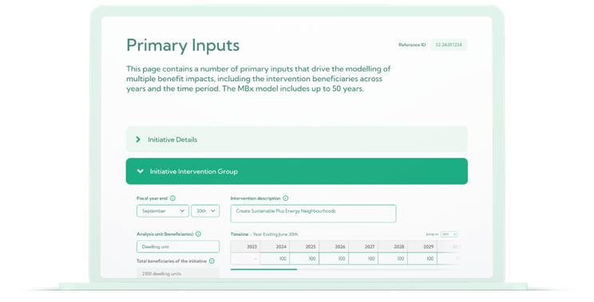

Cost Inputs

Here you have to enter the capital and operating expenditures related to the initiative i.e. the funding or investment being sought. These costs are calculated outside the MBx tool.  
  
  
Impact Database

Here you select each impact from the database that affects the intervention group (e.g. individuals, a subset of target population, families, dwellings etc.). You can also create your own impact and add it to the database.   
  
  
## Step 5 - Discount to a common period, compare with costs and benefits

MBx automatically completes this step once all the information has been input into the tool. Basically, the discount rate is used to discount impacts, costs and benefits that occur in the future to the base year (todays’ value, e.g. 2024). The discounted value is known as the present value. The Output Results presents a range of different calculations and graphs.

|  |
| --- |
| Sensitivity analysis involves working through some alternative scenarios  Running sensitivity analysis could be as simple as considering the impact of applying different discount rates. The MBx tool allows you to compare two or more Output results tab, where you can duplicate an initiative create new results by adjusting inputs (e.g. one with the standard discount rate and one with the alternative lower discount rate).  To do sensitivity analysis you can easily change the assumptions in MBx. For example, changing the segment, success rate or length of impacts. This can also be useful early in the initiative design process, to help focus effort where it matters most. The Sensitivity Analysis tab makes it easy to capture the sensitivity analysis.  Adjust different assumptions and scenarios in a new run of the model so you can compare the previous run. This does not affect the MBx calculations, rather it is a way to capture the different results so you can give a sense of the range.  Rules of thumb for assessing the return on investment  It is important to confirm that realistic assumptions have been used.   * If the wider-societal return on investment (ROI) is > 5, ensure that the impacts are not over estimated, and assumptions are not too optimistic. * If the ROI is around 2-5, it is highly likely that some impacts are overestimated or that tenuous impacts have been included. * If the ROI is around 1-2, the assumptions are likely to be more robust.   Common problems that can lead to overestimated impacts are:   * The “length of impact” assumption for specific impacts is too long and may double count for each impacted person / group. It is fine for the impacts to be long term, for example through “Time lag” assumptions. * Including groups more than once – check the primary input profile. * Over optimistic assumptions about success rate. |

Steps 6 to 7: Outputs from   
MBx tool

The main output (refer to table below) are the S-CBA summary metrics: **a net present value (NPV), a benefit-cost ratio (BCR) and overall return of an intervention (RoI).** The MBx tool allows you to print an A4 summary report with the S-CBA summary metrics and present value charts, together with the present value for specific impacts.

|  |
| --- |
| The outputs that may be of most interest:   * Lifetime net present value (NPV) of the initiative. * Lifetime NPV of individual impacts. * Return on investment (ROI) total (to the society and government). The ROI societal total is the same as the benefit cost ratio unless there are negative impacts. If there are negative impacts, then the benefit cost ratio will be different. * The Benefit- Cost Ratio (Total).   The user can also conduct a sensitivity analysis and also compare scenarios. |

## Step 6 - Is the result clear enough?

If not, consider whether it is worth investing in more research and analysis, and repeat the previous steps.

If the MBx results aren’t clear, you can run different scenarios to test the sensitivity to assumptions and consider obtaining additional information. You should decide whether it is worth investing in more research to get better information and improve quality of the S-CBA. It is important to weigh up the relevance of improved information and more research. The value of obtaining additional information should outweigh the cost.   
  
**Step 7** - Write report – provide advice

This step involves providing advice (for example, completing the relevant calculations and printing the report).

The report should:

* + Contain a problem definition of the initiative being addressed
  + Describe the initiative, including the intervention logic
  + Summarise any assumptions made
  + Contain any scenario/options analysis
  + List the identified non-quantified, quantified, and monetised impacts
  + Provide summary measures for example net present value (NPV), benefit cost ratio (BCR) and return on investment (ROI).

### Description of the outputs

|  |  |  |
| --- | --- | --- |
| Metrics (full period of analysis) | | Refer to the table below for summary of metrics presented in the outputs |
| Return on investment (RoI), Total | The ROI shows the impact per euro that the government (or investor) spends on an initiative.  The outputs summary presents a total ROI Total ROI considers all the impacts that have been modelled. | In this example, for every €1.00 euro spends on the SPEN, citizens receive about €1.1 worth of benefits. |
| Benefits cost ratio, Total | The BCR is the ratio of total discounted benefits to the total discounted costs across society. A proposal with a BCR greater than 1.0 has a positive net impact, because the multiple benefits (positive impacts) exceed the costs (negative impacts). | In this example, a Total benefit cost ratio of 1.1 is calculated indicating a higher net positive impact.  Additionally BCR Government and Wider societal are also presented to show the share of benefits accrued to the government (0.4) and wider society (0.7). |
| Net Present Value | The sum of the discounted benefits, less the sum of the discounted costs (relative to the business-as-usual). This gives a euro value representing the marginal impact of the initiative, in today’s euro terms. | In this example, a Net Present Value of €4m has been calculated representing Total Multiple benefits. |
| Un-monetised impacts | The impacts that could not be monetized. | In this example, a low number of unmonetized impacts were considered such as impact of shared infrastructure and increase in satisfaction levels. |
| Organisational assessment | **Value for money:** Select your best estimate on value for money. This does not impact on the MBx tool calculations but makes clear that the “Benefit-Costs” element which S-CBA informs is part of an overall value for money judgement. Overall, how do you consider the weight of the benefits and costs (including those non-monetised). Scale of 0 – No Returns-poor evidence to 5 – High returns- confident.  **Strategic alignment:** The intervention should align with Government priorities and strategies (in specific context). Judgement is required to assess how closely a proposal aligns with these and its relative importance eg, Budgets, sectoral goals and/or organisation obligations. Scale of 0 – No Alignment to 5 – Strong Alignment. | In this example, the value for money is selected to – 4- High return- Likely due to higher benefits over costs.  The proposed project aligns very well with the government priorities in Salzburg as well as the real estate company’s goals, therefore, 4- High alignment is selected. |

Return on investment summary table

This table provides a quick summary of the costs and impacts and overall ROI / BCR by discount rate applied and summarises the evidence quality associated with each.

|  |  |  |  |
| --- | --- | --- | --- |
| Summary Metrics provided in the MBx tool | Calculations of the Summary Metrics | Discount Rate – Real | Evidence Certainty |
| Initiative costs / investment present value €m | A | (70) [6] | High |
| Government impacts present value €m | B | 27 | Medium |
| Wider societal impacts present value €m | C | 47 | Medium |
| Total multiple benefits, net present value €m | = A + B + C | 4 | Medium |
| Un-monetised impacts | Magnitude | Low (+) | Low |
| Benefit cost ratio (BCR), Total (50y); BCR = ROI, unless there are negative impacts which the BCR includes in the denominator | = (Positive impacts B + C) / (A + Negative impacts B + C) | 1.1 | Medium |
| Return on Investment, Total (50y) | = (Positive impacts B + C) / (A + B + C) | 1.1 | Medium |
| Benefit cost ratio (BCR), Wider Societal only (50y) | = (Positive impacts C) / (A + Negative impacts C) | 0.7 | Low |
| Benefit cost ratio (BCR), Government only (50y) | = (Positive impacts B) / (A + Negative impacts B) | 0.4 | Low |

Net present value over time

This chart displays the profile of the impacts (net positive and negative impacts), the cost of the initiative, and the net present value over time. It also shows the cumulative net present value.

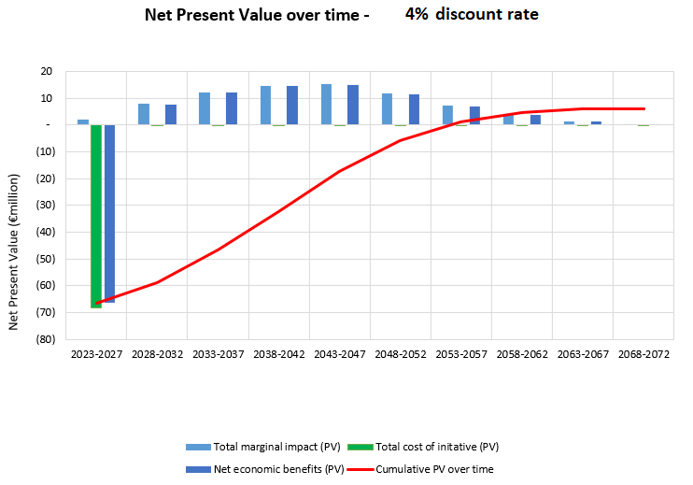

Present values of impacts across domains

This chart shows the total value over the 50-year timeframe, adjusted to present value (ie, today’s euros) by wellbeing domain. This view can quickly highlight surprising or significant results.

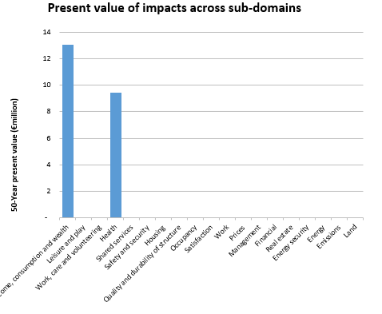

Marginal impact of intervention

Marginal impact refers to the specific change in an impact (before and after the intervention). Rather than focusing on the overall impact S-CBA focuses on the marginal change in an impact from an intervention, relative to the business-as-usual scenario.

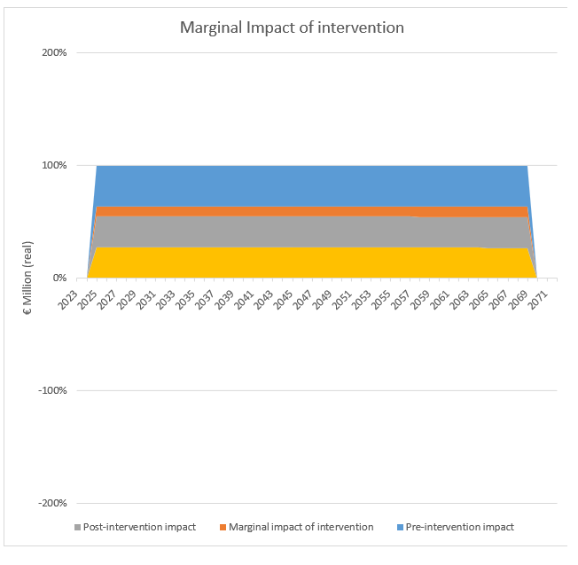

Cumulative net benefit

This chart displays the profile of cumulative net benefits accrued over time.

Impact summary table

This table summarises the impacts and the net values across 5-year, 10-year and 50-year time horizons in today’s euros. The table also highlights the quality of the evidence. The table gives a quick sense of which impact is driving the bulk of the overall return on investment (ie, look for the highest numbers).

Once you have finalised the MBx analysis, you should incorporate your findings into your advice. You can incorporate the monetised net present values for impacts and the overall results into the initiative report.

1. Referred to as Project or Policy  
   
2. referred to as Multiple benefits  
   
3. Referred to as Project or Policy  
   
4. Intervention group refers to the beneficiaries of the initiative such as people/population/dwellings/residents etc. impacted by the intervention.  
   
5.
6. Denoted as a negative value  
   